The new UK Immunological Toolbox website is now live!

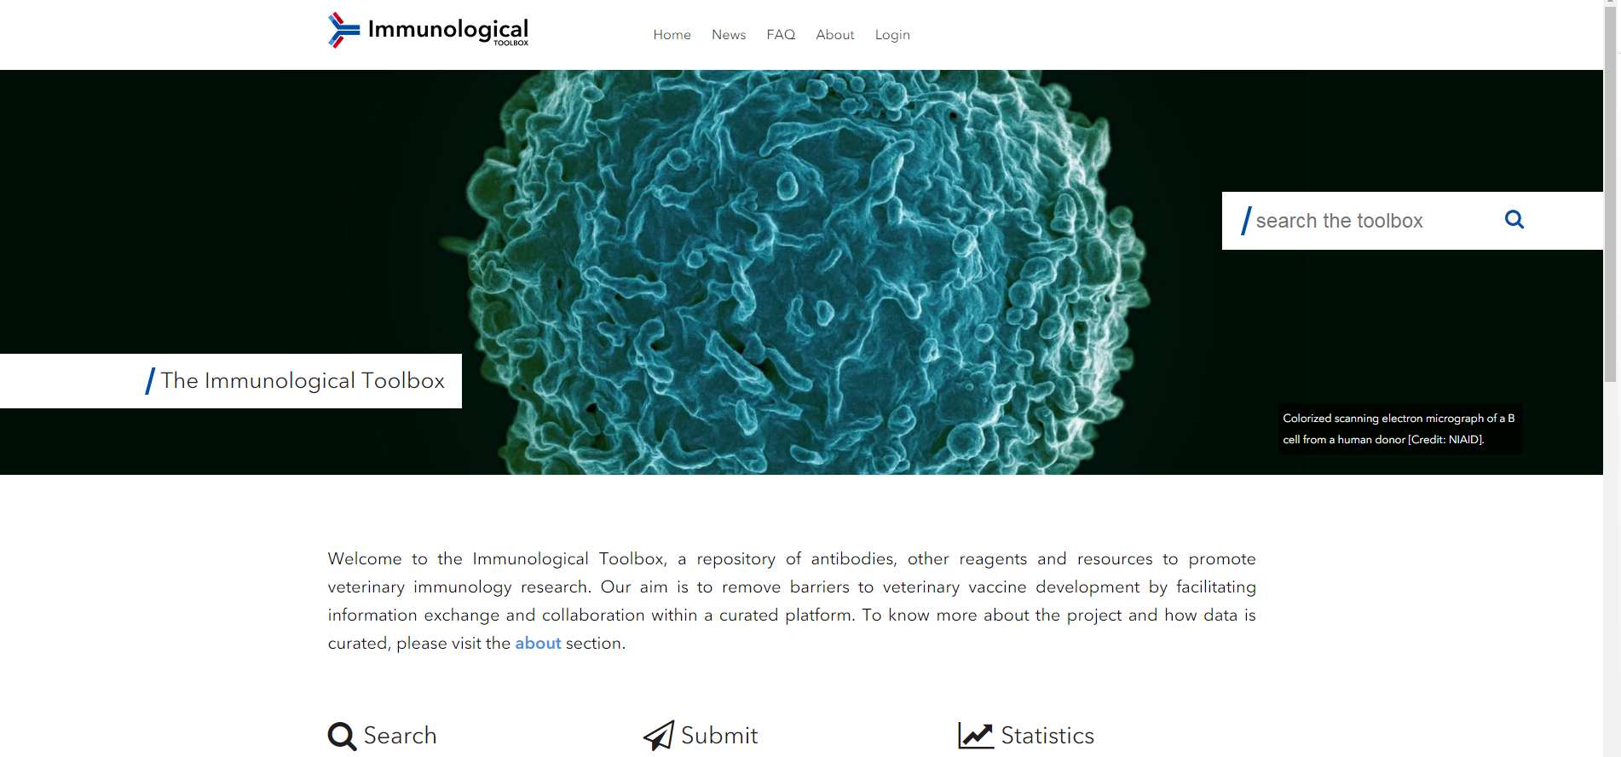

The UK Immunological Toolbox website (www.immunologicaltoolbox.co.uk/) collates and hosts information on reagents and resources to promote veterinary immunology and vaccinology research. Its aim is to remove barriers to veterinary vaccine development by facilitating accurate information exchange and collaboration through a central curated platform.

The initial focus has been on providing a centralised information repository for antibodies and recombinant proteins, available from commercial companies and through academic institutes. This basic information is displayed alongside descriptive data, species cross-reactivity, references, images and any other useful evidence that promotes their use. This website is now the most up-to-date and comprehensive repository available. It details over 1600 hybridomas producing well-characterised monoclonal antibodies (mAbs) and some polyclonal antibodies against cattle, chicken, pig, sheep, goat, horse and fish molecules. Both the number of reagents and species included will continue to increase as further information on unique institutional collections is received from around the world.

The UK Immunological Toolbox website is based around the antigenic molecules and is searchable using molecule name, species name or specific antibody name. A detailed but simple application table is displayed for each reagent which enables researchers to easily establish the utility of each reagent and rate them via an independent feedback system. Registered users can easily comment and submit supporting data, references and any other evidence that allows the community to better understand the utility of any reagent listed. Community engagement is a key component to maximising the utility of this website.

To make it easier for the research community to find the reagents, owner and/or supplier information is also prominently displayed on each reagent page and users are guided on whether the antibody is commercially available, available on request or in development. The next phase of Toolbox development will include specific details from genome variation through to isoforms, assays and expression patterns of target molecules.

The development of this website was supported by the UKRI-Biotechnology and Biological Sciences Research Council (UKRI-BBSRC) through the Global Challenges Research Fund (GCRF) grant BBS/OS/GC/000015. It is an output from the activities of the UK Immunological Toolbox initiative; the Immunological Toolbox project at The Pirbright Institute and at The Roslin Institute is supported by UKRI-BBSRC strategic funding.

For any queries on the Immunological Toolbox Database and Website or the UK Immunological Toolbox project, please contact: immunological.toolbox@pirbright.ac.uk or use the contact form on the website.

“Thanks for setting up the database and for all the work that you have put into it. I think it is a good start. The links to the commercial suppliers and the comments option is very nice.”
Prof. Dr. T. Göbel, Institute for Animal Physiology, LMU Munich

“The UK Immunological Toolbox website is an excellent resource for the veterinary immunology community. We have never before had a website where we could search for reagent specificity, backed-up with functional data and the facility to fill gaps in capability by commissioning reagent production. This really takes veterinary immunology forward in ways we have been struggling with for many years. I encourage all members of our community to use the website and contribute information on reagent specificity and function for the collective good.”
Prof. Gary Entrican, Chair of the IUIS Veterinary Immunology Committee

